**SUPERMARKET AUTOMATION SOFTWARE**

Software analysis and design

Vikram Raj

19STUCHH010121

Prepared for

Software Engineering Project CS413

Table of contents

1.Class Diagram 3

2. Sequence Diagram 4

* Sales Transaction 4
* View Sales Statistics 5
* ‘Update Inventory 5
* Update Price 6
* Add Employee 6

1. State Chart Diagrams 7
   * Log in 7
   * Sales Transaction 8
   * Printer 8
   * Sales Statistics 9
   * Automatic weighing machine 9
   * Bar Code Reader 10

CLASS DIAGRAM

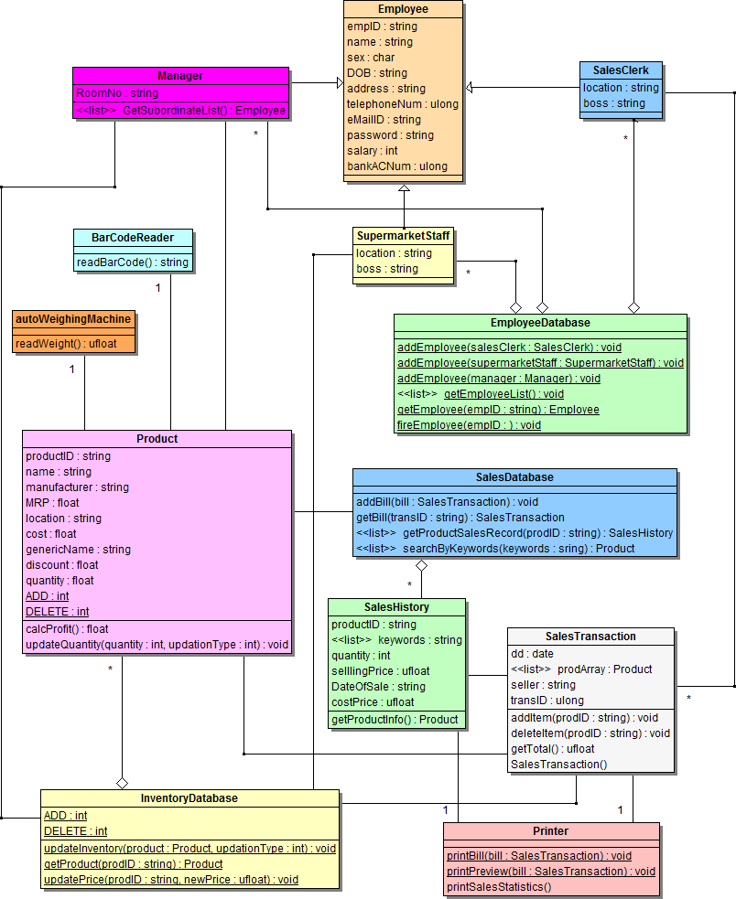

SEQUENCE DIAGRAMS

1. Sales Transaction

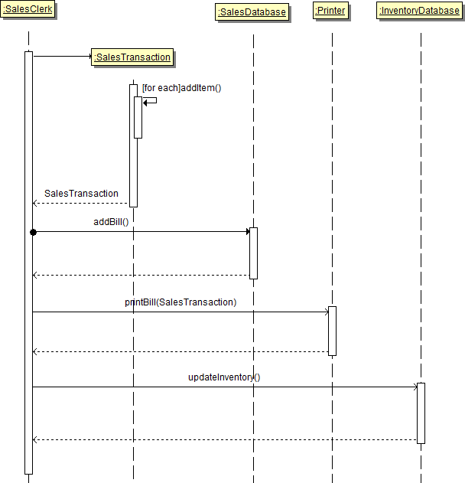

1. View Sales Statistics

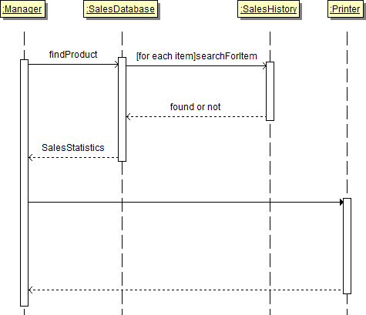

3. Update Inventory

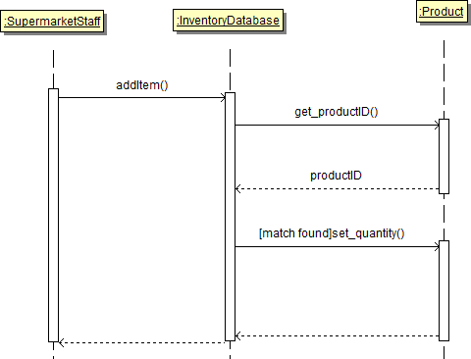

4. Update Price

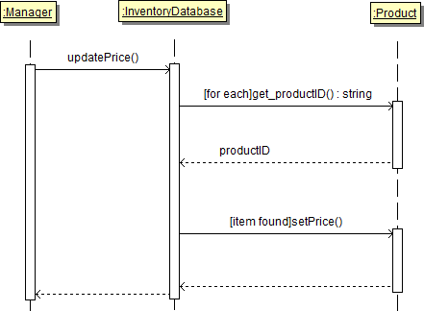

5. Add Employee

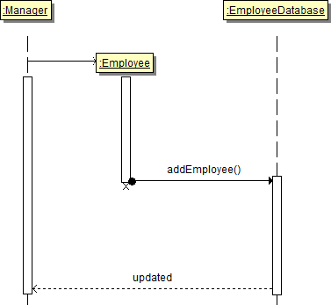

STATE CHART DIAGRAMS

**1. Log In**

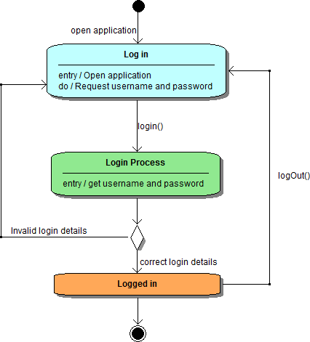

2. Sales Transaction

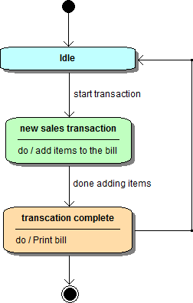

3. Printer

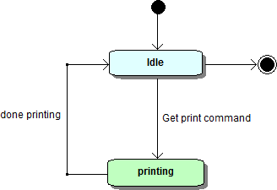

4. Sales Statistics

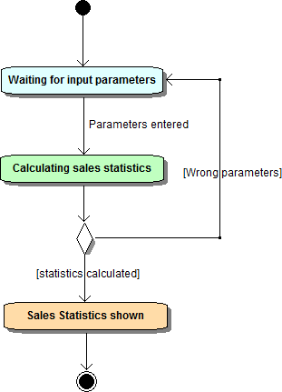

5. Automatic Weighing Machine

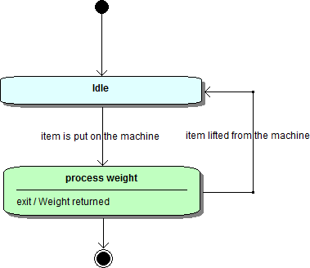

6. Bar code Reader

